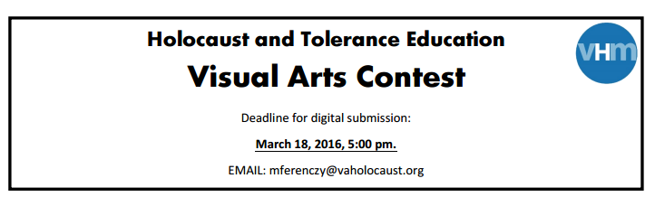
Name of Student: | Grade: 8
School: George H. Moody Middle School
Student Address:
Student Email:
Teacher or Sponsor: Lisa A. Chandler
Teacher or Sponsor Phone Number: (804) 874-8478
Teacher or Sponsor Email: lachandler@henrico.k12.va.us
Materials Used:
Title of Poster:
Artist’s Statement:
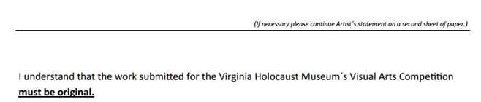

________________________________ _______________________________________
Date Signature

