MB Independent Research Project
Brainstorming Research…
Now that you know your code, what does it mean in terms of possible college majors and career fields for you? Revisit the two original MB websites to see what they say about good career “fits” for your code:
Test Site: http://www.humanmetrics.com/personality/type Scroll to the table of 16 types in the middle of the page and click on your code:
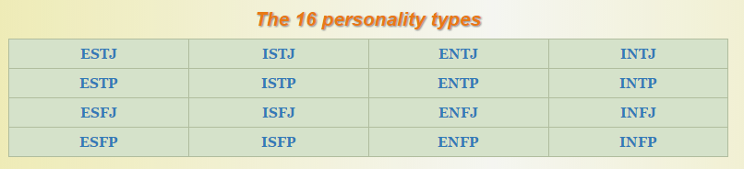Now, pick the “career choices” from menu items on right side.
Keirsey Site: http://www.keirsey.com/4temps/overview_temperaments.asp Find your code on the right side and click on it. Scroll to the bottom and click on “Best Job Fit for ____”.
Other sites for initial MB/Career connections…
http://www.truity.com/view/types Click on your type and explore career options.
http://faculty.ccbcmd.edu/~hzlotow1/MBTI/ Click on your type to see a career profile.
http://cms.bsu.edu/about/administrativeoffices/careercenter/explore/assessment/typefocus/whatpersonality Click on your type to read more about related majors and careers.

Research Topic Time!
Once you’ve settled on a career field/family (doesn’t have to be narrowed down yet - just enough to get you started) it’s time to determine your research focus…You decide where you want your research to take you! For example…
- Do you want to spend time researching a few different specific careers related to your selected field?
- Do you want to do in-depth research on one particular career?
- Do you want to research colleges that specialize in your selected field?
- Do you want to research global opportunities related to your career field?
- Do you have your own research plan?

In-Depth Research
Now that you know what you’re looking for, revisit any of the above sites to find more information, visit the Virginia Career View website ( http://www.vaview.vt.edu/68/ ) and click on links related to careers and career families, or conduct your own research to complete your Independent Research Project! Be sure to review the Independent Research Rubric as you research, reflect, and create your product

