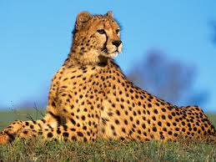
Cheetahs
Appearance

Fun Fact

Foods They Eat

Fun Fact

Name
Habitat

