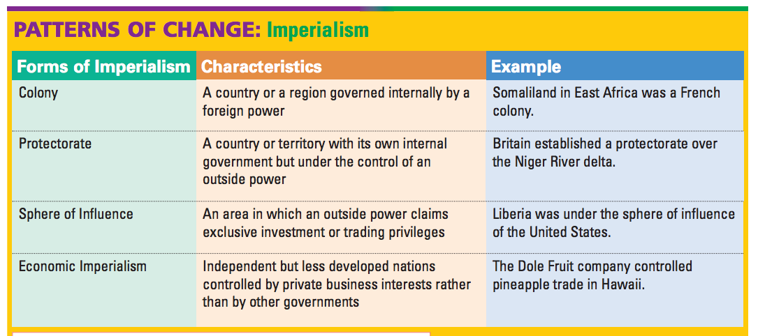

from: http://www.gcisd-k12.org/cms/lib/TX01000829/Centricity/Domain/829/27.2.pdf

