10th Grade Imperialism Inquiry
Do the Boxers Deserve
a Bad Rap?
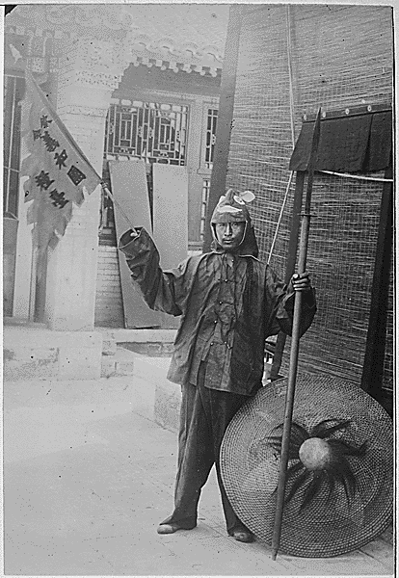

Department of the Army, Office of the Chief Signal Officer. “A Chinese Boxer, 1900.” Public domain. https://research.archives.gov/id/530870.

Supporting Questions
- How did the Opium Wars create foreign influence in China and how did the Chinese react?
- What were the goals and consequences of Christian missions in China and why did the Boxers object to these?
- What happened during the Boxer Rebellion?
- To what extent were the Boxers misunderstood?

10th Grade Imperialism Inquiry

Do the Boxers Deserve a Bad Rap?
New York State Social Studies Framework Key Idea & Practices | 10.4 IMPERIALISM: Western European interactions with Africa and Asia shifted from limited regional contacts along the coast to greater influence and connections throughout these regions. Competing industrialized states sought to control and transport raw materials and create new markets across the world.   Gathering, Using, and Interpreting Evidence Chronological Reasoning and Causation
Staging the Question | Analyze a Harper’s Weekly political cartoon and discuss who students think the Boxers were and how people in the United States viewed them.

Supporting Question 1 |  | Supporting Question 2 |  | Supporting Question 3 |  | Supporting Question 4
How did the Opium Wars create foreign influence in China and how did the Chinese react? |  | What were the goals and consequences of Christian missions in China and why did the Boxers object? |  | What happened during the Boxer Rebellion? |  | To what extent were the Boxers misunderstood?
Formative  Performance Task |  | Formative  Performance Task |  | Formative  Performance Task |  | Formative  Performance Task
Write 2–3 sentences describing how the Opium Wars created foreign influences in China and the Chinese reactions. |  | Write a paragraph explaining the goals of Christian missionaries in China and describing the Boxers’ perspective on these missions. |  | Create a two-column chart that explains the events of the Boxer Rebellion through the perspectives described in the featured sources. |  | Develop a claim supported by evidence that explains to what extent the Boxers were misunderstood.
Featured Sources |  | Featured Sources |  | Featured Sources |  | Featured Sources
Source A: Excerpt from “The Opium War and Foreign Encroachment” |  | Source A: “American Missionaries in China”  Source B: Letter from Hua-Cheng Kwei to the Holy Union Mission in Sweden. |  | Source A: Excerpt from Fei Ch'i-hao’s account of the Boxer Rebellion  Source B: Excerpt from Luella Minor’s account of the Boxer Rebellion |  | Source A: Excerpt from “Remembering the Boxer Uprising: A Righteous Fist”  Source B: Excerpt from “The Open Door Policy and the Boxer War: The US and China”  Source C: Excerpt from “The Boxer Rebellion”

Summative Performance Task | ARGUMENT Do the Boxers deserve a bad rap? Construct an argument (e.g., detailed outline, poster, essay) that addresses the compelling question using specific claims and relevant evidence from historical sources while acknowledging competing perspectives.
Summative Performance Task | EXTENSION Create textbook entries that express how the Boxer Rebellion should be represented in textbooks.
Taking Informed Action | UNDERSTAND Research China’s recent ventures with imperialism in Africa.  ASSESS Weigh the benefits and consequences of these actions for China, Africa, and the United States.  ACT Write an op-ed piece that brings awareness to the issue and use evidence to make claims that support or criticize China’s actions.

Overview

Inquiry Description
Between 1899 and 1901, in what became known as the Boxer Rebellion, a Chinese secret organization called the Society of the Righteous and Harmonious Fists led an uprising in northern China against foreign imperialism and associated Christian missionary activity. Western powers, including the United States, intervened and defeated Chinese forces. This inquiry investigates the multifaceted views of imperialism in China during the late 19th and early 20th centuries by investigating the compelling question “Do the Boxers deserve a bad rap?” Students consider not only the brutal events of the Boxer Rebellion in China, but also the reasons why the Boxers rebelled against foreign powers in the first place. While progressing through the inquiry, students consider the political, economic, and religious reasons for both imperialism and the Boxer Rebellion. Students then consider the actions of the Boxers and whether or not those actions might be misunderstood.
In addition to the Key Idea listed earlier, this inquiry highlights the following Conceptual Understanding:
- (10.4b) Those who faced being colonized engaged in varying forms of resistance and adaptation to colonial rule with varying degrees of success.
NOTE: This inquiry is expected to take four to six 40-minute class periods. The inquiry time frame could expand if teachers think their students need additional instructional experiences (i.e., supporting questions, formative performance tasks, and featured sources). Inquiries are not scripts, so teachers are encouraged to modify and adapt them to meet the needs and interests of their particular students. Resources can also be modified as necessary to meet individualized education programs (IEPs) or Section 504 Plans for students with disabilities.

Structure of the Inquiry
In addressing the compelling question “Do the Boxers deserve a bad rap?” students work through a series of supporting questions, formative performance tasks, and featured sources in order to construct an argument with evidence while acknowledging competing perspectives.

Staging the Compelling Question
Teachers could stage the compelling question by using the political cartoon The Boxers, printed in Harper’s Weekly in 1900. The political cartoon could be used to spark discussion about who students think the Boxers were and how they think people in the United States viewed them. Students might also consider symbols such as Uncle Sam’s boxing gloves as well as exaggerations such as the depiction of the Chinese rebel. Teachers should point out the stereotypes and exaggerations drawn in the cartoon and may ask, “Who do you think drew this cartoon and why?” or “What does this cartoon tell you about Western perceptions of the Chinese?” A resource guide helpful to students as they analyze political cartoons can be found at the Library of Congress: http://www.loc.gov/teachers/classroommaterials/presentationsandactivities/activities/political-cartoon/cag.html

Supporting Question 1
The first supporting question—“How did the Opium Wars create foreign influence in China and how did the Chinese react?”—focuses on the political and economic benefits westerners achieved through imperialism in China. The featured source is an excerpt about the Opium Wars and how they contributed to foreign influence in China The formative performance task calls on students to write a 2- to 3-sentence summary of the source describing how the Opium Wars created foreign influences and how the Chinese reacted to these events.

Supporting Question 2
In the second supporting question—“What were the goals and consequences of Christian missions in China and why did the Boxers object to these?”—students turn their attention to religion and its role in imperialism. For the formative performance task, students write a paragraph explaining the goals of Christian missionaries in China and describing the Boxers’ perspective on these efforts. The first featured source is an overview by historian Walter LaFeber of the missionaries and their reception in China. The second featured source is a letter sent by a Chinese Christian to the mission center in Sweden during the Boxer Rebellion.

Supporting Question 3
The third supporting question—“What happened during the Boxer Rebellion?”—allows students to investigate the difficult and sometimes brutal details of the Boxer Rebellion through first-person accounts of the events. For this formative performance task, students create a two-column chart that explains the events of the Boxer Rebellion through each of the first-person perspectives provided in the featured sources. The first featured source is an account by Fei Ch'i-hao, a Chinese Christian during the rebellion. The second featured source is the perspective of Luella Minor, a professor at the American College at Tungchau. As students complete their charts, teachers should guide them to include not only the details of what happened, but also, when appropriate, the emotional reactions of the participants.

Supporting Question 4
The final supporting question—“To what extent were the Boxers misunderstood?”—calls on students to consider how the Chinese viewed the Boxers and whether or not their rebellion has been misunderstood by westerners. For this formative performance task, students develop a claim using evidence that answers the supporting question. The first featured source is an excerpt from The Economist that details why the Boxers might be considered “misguided patriots.” The second and third featured sources are excerpts from historians Walter LaFeber and Warren Cohen that highlight the complex history of the Boxers, including their veneration in China and the development of myths by the West.

Summative Performance Task
At this point in the inquiry students have considered the Western political, economic, and religious goals of imperialism and the Boxers’ actions in response. Students have also examined the brutal events of the Boxer Rebellion and considered whether or not the Boxers might be misunderstood. Students should be expected to demonstrate the breadth of their understandings and their abilities to use evidence from multiple sources to support their distinct claims. In this task, students construct an evidence-based argument responding to the compelling question “Do the Boxers deserve a bad rap?” It is important to note that students’ arguments could take a variety of forms, including a detailed outline, poster, or essay.
Students’ arguments likely will vary, but could include any of the following:
- The Boxers deserve a bad rap because of their brutality and intolerance against foreign powers, missionaries, and Chinese citizens.
- The Boxers do not deserve a bad rap because their rebellion was a reaction to the exploitation of the country, both economically and culturally, by foreign powers.
- The Boxers might deserve a bad rap because, although brutal at times, their rebellion was also a defensive response to foreign missionaries and Western culture overtaking their way of life.
Students could extend their arguments by creating textbook entries (i.e., text and pictures) that represents their views on how the Boxer Rebellion should be represented in history books.
Students have the opportunity to Take Informed Action by drawing on their knowledge of the costs and benefits of imperialism. They demonstrate that they understand by researching how China may be considered new imperialists in Africa. Students could begin by reading the New Yorker article “China in Africa: The New Imperialists?” (http://www.newyorker.com/news/news-desk/china-in-africa-the-new-imperialists) and supplement their findings with other research. Students show their ability to assess by examining the benefits and consequences of these actions for China, Africa, and other nations such as the United States. And they act by writing an op-ed that brings awareness to the issue and uses evidence to make claims that support or criticize China’s actions.

Staging the Compelling Question
Featured Source | William Allen Rogers, political cartoon about the relationship between the United States and the Boxers, “The Boxers,” Harpers Weekly, June 9, 1900

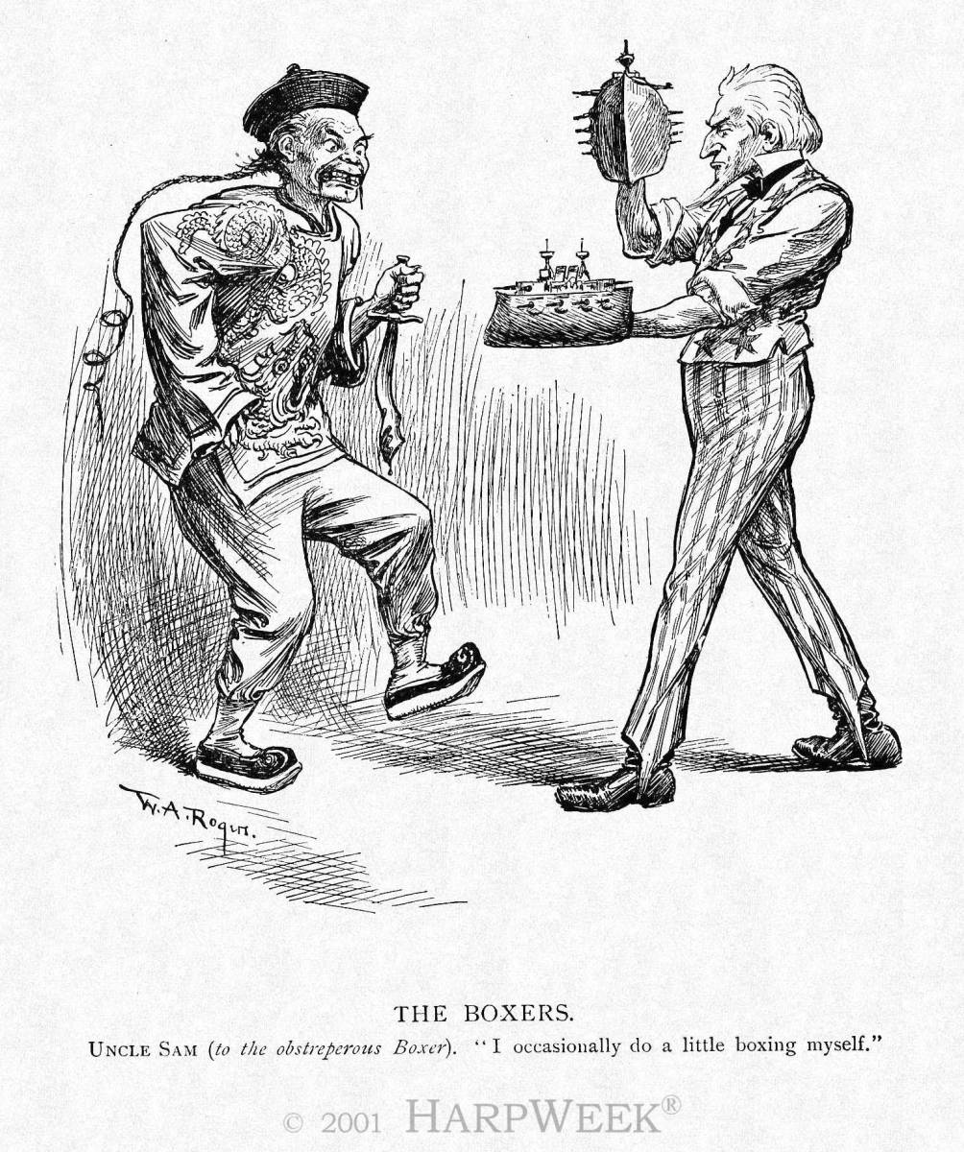

Uncle Sam (to the obstreperous Boxer). "I occasionally do a little boxing myself." Public domain.

Supporting Question 1
Featured Source | Source A: Sue Gronewold, article describing the causes of the Opium War, “The Opium War and Foreign Encroachment” (excerpt), Asia for Educators, 2009

Two things happened in the eighteenth century that made it difficult for England to balance its trade with the East. First, the British became a nation of tea drinkers and the demand for Chinese tea rose astronomically. It is estimated that the average London worker spent five percent of his or her total household budget on tea. Second, northern Chinese merchants began to ship Chinese cotton from the interior to the south to compete with the Indian cotton that Britain had used to help pay for its tea consumption habits. To prevent a trade imbalance, the British tried to sell more of their own products to China, but there was not much demand for heavy woolen fabrics in a country accustomed to either cotton padding or silk.

The only solution was to increase the amount of Indian goods to pay for these Chinese luxuries, and increasingly in the seventeenth and eighteenth centuries the item provided to China was Bengal opium. With greater opium supplies had naturally come an increase in demand and usage throughout the country, in spite of repeated prohibitions by the Chinese government and officials. The British did all they could to increase the trade: They bribed officials, helped the Chinese work out elaborate smuggling schemes to get the opium into China's interior, and distributed free samples of the drug to innocent victims.

The cost to China was enormous. The drug weakened a large percentage of the population (some estimate that 10 percent of the population regularly used opium by the late nineteenth century), and silver began to flow out of the country to pay for the opium. Many of the economic problems China faced later were either directly or indirectly traced to the opium trade. The government debated about whether to legalize the drug through a government monopoly like that on salt, hoping to barter Chinese goods in return for opium. But since the Chinese were fully aware of the harms of addiction, in 1838 the emperor decided to send one of his most able officials, Lin Tse-hsu (Lin Zexu, 1785-1850), to Canton (Guangzhou) to do whatever necessary to end the traffic forever.

Lin was able to put his first two proposals into effect easily. Addicts were rounded up, forcibly treated, and taken off the habit, and domestic drug dealers were harshly punished. His third objective — to confiscate foreign stores and force foreign merchants to sign pledges of good conduct, agreeing never to trade in opium and to be punished by Chinese law if ever found in violation — eventually brought war. Opinion in England was divided: Some British did indeed feel morally uneasy about the trade, but they were overruled by those who wanted to increase England's China trade and teach the arrogant Chinese a good lesson. Western military weapons, including percussion lock muskets, heavy artillery, and paddlewheel gunboats, were far superior to China's. Britain's troops had recently been toughened in the Napoleonic wars, and Britain could muster garrisons, warships, and provisions from its nearby colonies in Southeast Asia and India. The result was a disaster for the Chinese. By the summer of 1842 British ships were victorious and were even preparing to shell the old capital, Nanking (Nanjing), in central China. The emperor therefore had no choice but to accept the British demands and sign a peace agreement. This agreement, the first of the "unequal treaties," opened China to the West and marked the beginning of Western exploitation of the nation.

Reprinted courtesy of Asia for Educators, Weatherhead East Asian Institute, Columbia University. http://afe.easia.columbia.edu/special/china_1750_opium.htm#letter

Supporting Question 2
Featured Source | Source A: Walter Lefeber, interview transcript describing perceptions of Missionaries in China, “American Missionaries in China,” Public Broadcasting System, 2006

US officials thought that American missionaries were very important for American interests, not just for missionary interest, but overall American interest in China. And the reason was that, for example, once American missionaries were able to get into interior provinces of China, it opened these provinces up to American business people, and consequently American diplomatic officials on the scene nicely call the American missionaries the pioneers for American trade and business, because once they opened up an area, then the other Americans could come along behind and sell goods. The American missionaries did something else. They essentially exemplified an American lifestyle. They used American products. They were people who believed that American products were the best products. And so along with their faith, they brought in American industrial goods and farm products. And, as a result the American missionaries became really front people for American exporters and American businessmen. The Chinese did not miss this. When the Chinese looked at American missionaries, or other foreign missionaries, they essentially saw them not just as people who were crusading with a faith, but who were trying to sell goods and to Westernize their particular society. And, as a consequence it is not, I think, surprising that the Chinese revolutionaries, particularly the Boxers, would target the missionaries because they saw in missionaries not only Christians, which they had doubts about, but also they saw in the missionaries the whole cutting edge for an American lifestyle and an American product that they believed was essentially undermining the Chinese village, the Chinese traditions, and Chinese control over their own territory.
On the one hand, as the American minister to China says, "They're the pioneers for American trade and commerce." On the other, they are the moral cutting edge of -- of the American mission in China. They are the American -- the side of American diplomacy that is moral, that is uplifting, that wants to Christianize China and make it a better nation. McKinley is very close to the missionaries. He is greatly concerned about the missionaries. He's a devout Christian himself and he believes that the missionaries have a legitimate role in China and it goes beyond simply acting as commercial agents. It is really to propagate the faith in China and to make the Chinese a better people by converting them.

From American Experience, America 1900, © 1996-2015 WGBH Educational Foundation.
http://www.pbs.org/wgbh/amex/1900/filmmore/reference/interview/lafeber_americanmissionar.html

Supporting Question 2
Featured Source | Source B: Hua-Cheng Kwei, letter to the Holy Union Mission in Sweden, 1900

NOTE: C&MA is an acronym for Christian and Missionary Alliance; C.I.M is an acronym for China Inland Mission.

Dear Pastor Kilstet,

How wonderful is the Lord in all His doings! Who is able to understand His ways? Dear Mission Friends, you have probably heard how the storms of persecution have broken out in China, and have also reached up to Shansi to your field of labor and ours of the C&MA, and the C. I. M. have also gotten their share of it. After Mr. Lundeberg told how the ten missionaries of the Holy Union Mission were killed, and amongst them Mr. and Mrs. Forsberg, of our mission, and their child—the missionaries were stoned and the child torn in pieces. The riot began in Kwei-Hua-Cheng where we were, so we left the place and thought to go to Urza, and over to Russia, but when we were two days journey from Kwei Thea, all of our things were stolen from us, the robbers attacking us eight times. They took some of our clothing from our bodies so we had to suffer both hunger and cold. Four Catholic missionaries at that place heard about us and sent messengers after us to bring us here. The last messenger found us and we have been here eight days, but here also there is great danger. The Boxers are coming to destroy the place. Many Catholic settlements were spoiled and thousands of Chinese were killed and our station we know was destroyed.

We do not know anything about the other missionaries, but with us here of the C&MA Mr. and Mrs. Emil Olson and their three children, Mr. and Mrs. Edvin Andersson, and their two children, Miss Emilie Erickson, and Mrs. Carl Lundberg and their children. If we should not come out with our lives then please send our last message to all mission friends. We live and die for the Lord and China. The way to the coast is not open. We have not heard anything from Peking for nearly two months, but the way to the Lord is open, thanks be to Him. Let not your hands fail and do not lose your courage. What we sow shall bear fruit in its time. When the storm is over send out other witnesses to China to proclaim the great act of the Lord. I do not regret that I came to China. I know the Lord called me here, and his grace is enough for me. The way he leadeth is the best, His will be done. We shall meet at his right hand.

The Christian and Missionary Alliance. Used with permission. https://www.cmalliance.org/about/history/in-the-line-of-fire/boxer-rebellion

Supporting Question 3
Featured Source | Source A: Fei Ch'i-hao, account of the Boxer Rebellion, “The Boxer Rebellion, 1900.”

The people of Shansi are naturally timid and gentle, not given to making disturbances, being the most peaceable people in China. So our Shansi Christians were hopeful for themselves, even when the reports from the coast grew more alarming. But there was one thing which caused us deep apprehension, and that was the fact that the wicked, cruel YU Hsien, the hater of foreigners, was the newly appointed Governor of Shansi. He had previously promoted the Boxer movement in Shantung, and had persuaded the Empress Dowager that the Boxers had supernatural powers and were true patriots.
Early in June my college friend K'ung Hsiang Hsi came back from T'ungchou for his vacation, reporting that the state of affairs there and at Peking was growing worse, that the local officials were powerless against the Boxers, and that the Boxers, armed with swords, were constantly threatening Christians scattered in the country.
From this time we had no communication with Tientsin or Peking. All travellers were searched, and if discovered bearing foreign letters they were killed. So though several times messengers were started out to carry our letters to the coast, they were turned back by the Boxers before they had gone far. It was not long before the Boxers, like a pestilence, had spread all over Shansi. School had not closed yet in Fen Chou Fu, but as the feeling of alarm deepened, fathers came to take their boys home, and school was dismissed before the end of June….
The wicked Governor, Yü Hsien, scattered proclamations broadcast. These stated that the foreign religions overthrew morality and inflamed men to do evil, so now gods and men were stirred up against them, and Heaven's legions had been sent to exterminate the foreign devils. Moreover there were the Boxers, faithful to their sovereign, loyal to their country, determined to unite in wiping out the foreign religion. He also offered a reward to all who killed foreigners, either titles or office or money. When the highest official in the province took such a stand in favor of the Boxers, what could inferior officials do? People and officials bowed to his will, and all who enlisted as Boxers were in high favor. It was a time of license and anarchy, when not only Christians were killed, but hundreds of others against whom individual Boxers had a grudge.
Crowds of people kept passing our mission gate to see what might be happening, for the city was full of rumors. "The foreigners have all fled."
"Many foreigners from other places have gathered here."
"A great cannon has been mounted at the mission gate."
"The foreigners have hired men to poison wells, and to smear gates with blood."
I was staying in the compound with the Prices, inside the west gate of the city, and Mr. and Mrs. Atwater, with their children, Bertha and Celia, lived near the east gate. On the 28th of June all day long a mob of one or two hundred roughs, with crowds of boys, stood at the gate of the Atwater place, shouting:
"Kill the foreigners, loot the houses."
Public domain. Miner, Luella, Two Heroes of Cathay, (N.Y.: Fleming H. Revell, 1907), pp. 63-128. Text appears as part of the Internet Modern History Sourcebook, Fordham University. http://legacy.fordham.edu/halsall/mod/1900Fei-boxers.asp

Supporting Question 3
Featured Source | Source B: Luella Miner, account of the Boxer Rebellion, “Miner Luella, A Prisoner in Peking” (excerpts), Outlook, 1900

June 15: About ten o'clock the most horrible noise began in the southern city, just on the opposite side of the city wall. It was a horde of Boxers going through their rites, burning incense, crying, "Kill the foreign devils! Kill the secondary foreign devils! (Christians). Kill! Kill! Kill!" They called other things, but I could only distinguish the "kill!" There may have been from twenty to fifty thousand voices, not all Boxers, swelling that mad tumult. After two or three hours the noise suddenly ceased. The Boxers in their indiscriminate pillaging had looted a Mohammedan bank. The Mohammedans gathered a band of three hundred, pursued them, and got back their money, after which the mob dispersed.
Our lines of defense have been extended to include all the streets bordering on this mission property - three or four streets and alleys being under martial law - and all passers-by are challenged. The same conditions prevail on Legation Street - stray Boxers are captured and passers-by are challenged. The missionaries and Chinese who have weapons all help in guard duty. There are barbed-wire barricades at the end of each street….
Now, in the compound and adjoining streets we have barricade within barricade of barbed wire or brick, all the walls and some of the small buildings having been torn up to get brick. This is said to be the best fortified place in the city now, thanks to the free labor of our numerous refugees, and if we had a Gatling or machine gun we would feel quite safe….
June 18: We have now spent ten full days in this place, and may be obliged to spend many more, for we can get no word from our foreign troops who left Tientsin a week ago yesterday….
We are more effectively cut off from the world than ever, for no couriers can now be found to carry mail to Tientsin for the Imperial post-office. . . We have been surprised that they have succeeded in keeping up the service so long. We hope that in two or three days communication will be open again. We hear that vast numbers of Boxers attacked the railroad station in Tientsin and were repulsed with great slaughter. It is rumored that the relief army is now only ten or fifteen miles from us, but we cannot be sure.
Placards are being distributed everywhere in the city commanding that this place and Legation Street be destroyed today….
Over seventy of us American missionaries live, eat, and sleep in the little church at the British Legation, though a few of the ladies sleep in Lady Macdonald's ballroom, two or three in the billiard-room, and some of the men outdoors. In the church we all sleep on the floor or on the church seats. There are thirty-five in our Congregational crowd, about twenty Methodists, and sixteen Presbyterians. We eat by denominations, but there is only one tiny stove to cook over, so we cannot cook much. If we are besieged long, we shall have to go on short rations. In fact, we are now leaving most of the canned meats for the men, who are doing hard work outside, watching and fortifying….
August 14: At last our ears have heard the sweet music for which we have been listening for two months - the cannonading of the relief army - so plainly that we know that intense desire and imagination are not deceiving us, as so many times before. Our deliverance is at hand. Last night was a fearful one. There were at least six distinct attacks, the first beginning about eight in the evening, and there was almost incessant firing between these attacks. Our implacable foes seemed determined to use to the utmost this last chance to wipe us out. Our garrison returned fire more than at any other time, for now they are not afraid of exhausting their ammunition….
It was a little after two in the afternoon, as I was sitting writing under the trees in the tennis-court, where I have spent so many hours during these past weeks, when an American marine from the city wall ran into the yard shouting, "The troops are inside the city - almost here!" There was a wild rush for the south end of the compound, and there, sheltered by the barricades, we stood and saw the first of the relief army straggling up the streets. And who do you think they were? Black-faced, high-turbaned troops, Rajpunts from India - great, fierce-looking fellows, but their faces were beaming with joy, and they hurrahed louder than we did. There were British officers with them, and one of them stooped in passing and kissed a pale-faced girlie who looked as if she needed to be rescued by a relief army. All that afternoon the troops came streaming in, Sihks, Bengal Lancers; English soldiers, and, most welcome of all, our American boys."
Public domain. Miner Luella, “A Prisoner in Peking, 1900.” http://www.eyewitnesstohistory.com/boxer.htm

Supporting Question 4
Featured Source | Source A: Economist staff, Chinese account of the Boxer Rebellion, “Remembering the Boxer Uprising: Righteous Fist” (excerpts), The Economist, 2010

The Boxer Uprising, 11 years before the collapse of China's last imperial dynasty, was portrayed in Western accounts as a savage outburst of primitive xenophobia directed at the West and its civilising religion, Christianity. The northern Chinese peasants with their red headscarves, who believed in a magic that protected them from foreign bullets and in the power of ancient martial arts that could defeat the industrial world's most powerful armies, were described with a mixture of fear and racist scorn. But in China the Boxers are officially remembered as somewhat misguided patriots. In the countryside south of Beijing where they burned churches, killed foreign missionaries and slaughtered tens of thousands of “secondary hairy ones”, as Chinese converts to Christianity were known, some call them heroes. The missionaries they attacked had it coming, having trampled on China's sovereignty. Their converts were no more than local ruffians who exploited foreign protection to ride roughshod over their countrymen….

Ever since the uprising, memories of it have troubled the relationship between China and the West. For the West, “Boxerism” became synonymous with a rabid, anti-foreign demon that was thought to lurk in China, ready to wreak bloody havoc if given a chance. As The Economist advised its readers in 1905: “The history of the Boxer movement contains abundant warnings as to the necessity of an attitude of constant vigilance on the part of the European Powers when there are any symptoms that a wave of nationalism is about to sweep over the Celestial Empire.”

© The Economist Newspaper Limited, London December 16, 2010. http://www.economist.com/node/17723014

Supporting Question 4
Featured Source | Source B: Warren I. Cohen, description of the complex nature of the Boxer’s Rebellion, “The Open Door Policy and the Boxer War: The US and China,” Gilder Lehrman, no date

The months that followed Hay’s notes were not marked by reforms leading to the modernization of China’s government or society. At the time of the American initiative in 1899, opponents of reform, led by Cixi, the empress dowager, were in control in Beijing. She and her supporters were channeling unrest in North China into an antiforeign movement led by men known as the Boxers—a loose amalgam of martial arts and invulnerability ritual societies. The destruction of missionary properties and murder of Chinese Christians intensified and could not be ignored.
The United States joined several European nations in demanding that the Chinese government put an end to the outrages, but to no avail. To the magic powers allegedly possessed by the Boxers, Cixi added the modern weapons of the imperial army. She called the Boxers to Beijing and ordered the massacre of all foreigners, including the diplomatic community. The legation quarter became an embattled fortress, subject to incessant attack, cut off from outside contacts.
The war with Spain had brought American troops to the Philippines and suppression of a Filipino insurrection had required their continued presence in East Asia. With the lives of American diplomats, businessmen, and missionaries endangered in China, the McKinley administration had both the resources and the will to protect its people and their interests against the Chinese. Several thousand Americans were among the troops that ultimately defeated the Boxers and lifted the siege of the legation. Long before they reached Beijing, however, Hay had sent off a second round of Open Door notes.
As the Boxer War began, Hay feared the collapse and dismemberment of China. It seemed likely that the powers generally and the Russians in particular would find Chinese provocations sufficient to justify further encroachments on Chinese sovereignty. Once the foreign armies fought their way to Beijing, they would not be removed easily—and it might prove very difficult to protect American interests.
In July 1900, Hay sent off a circular message expressing concern for the preservation of Chinese sovereignty, the “territorial and administrative entity” of China. Hoping to contain the war to North China, Hay defined the situation as a state of virtual anarchy in which power and responsibility rested with local authorities. The McKinley administration worked with high-ranking Chinese officials who controlled southern and central provinces, suppressed the Boxers and protected foreigners and their property. Together they established the myth that the Boxers were acting spontaneously, rebelling against the Chinese government as well as attacking foreigners. Thus the war could be limited in area and intensity and the possible partition of China forestalled.
The Gilder Lehrman Institute of American History. http://www.gilderlehrman.org/history-by-era/empire-building/essays/open-door-policy-and-boxer-war-us-and-china

Supporting Question 4
Featured Source | Source C: Walter Lefeber, interview transcript describing the Boxer Rebellion, “The Boxer Rebellion,” Public Broadcasting System (excerpts), 2006

The Boxer Rebellion erupted in China in late 1899 and really reached a peak in the early part of 1900. The Boxers came from the north of China. They were largely peasants. About 70 percent of all the Boxers were peasants, it seems like. And they particularly were concerned about the westernization of their land. They targeted western railroad entrepreneurs. They targeted foreign missionaries. The Boxers actually had, as many Chinese had, great doubts about railroads. They weren't sure that they wanted railroads and one of the reasons they did not want railroads is because they identified railroads with westernization and they weren't sure they wanted westernization. As a consequence, by the early part of 1900, the Boxers have killed a number of foreign missionaries. They are beginning to kill engineers, foreign engineers, foreign business people, and they begin to move out of the north and in the spring of 1900 this mass movement this mass Chinese revolutionary movement is targeting Beijing, the capital of China, and particularly the foreign compound in Beijing where all of the foreign diplomats and many of the foreign business people live and in the early summer of 1900 they lay siege to this foreign compound. And everyone understands that if this siege succeed, that they are probably going to massacre all of the foreigners that they can get their hands on….

In the summer of 1900, as the Boxers are besieging the foreign ligation in Beijing and threatening to kill all of the foreigners they can get their hands on, McKinley has to make a historic decision. And the decision is whether or not to send US troops out of Manila and onto the mainland of Asia. Obviously, American troops had never fought in this theater before and what McKinley does is not only order the troops onto the Asian mainland to fight in China, but he does it without consulting anyone. He essentially goes to war without asking Congress anything about it. He uses his commander-in-chief powers and it becomes a very important point historic precedent, the kind of precedent that later American Presidents will use to order American troops around the world. So American troops are now on the China mainland fighting with other imperial powers. We have never been able to figure out exactly what the command structure of this was. It was so complex. But in the end, the foreign forces won simply because there were 20,000 of them, they had overwhelming power, particularly fire power, and they were absolutely brutal in the way that they used it. There are now vivid pictures of the Boxers rebels who were captured being decapitated with their heads put on poles outside the ligations. So that the Chinese would get the idea that they were never to try this again. McKinley participated fully in this. He understood that unless the United States became involved in this intervention, that the other powers would do what they wanted to do in China. And McKinley found that intolerable. He believed that we had a role in China, that, indeed, we had a destiny in China, that we had to keep China whole, and he was willing to commit American forces so that he could preserve the China market for American goods and for American missionaries….

The outcome of the Boxer Rebellion is in a short term the United States and the other imperial powers won and beat back the Boxers and massacred a number of the Boxers. In the long term, we can now see that it was the beginning of the Chinese Revolution, that the Chinese saw this as something that they would have to organize themselves to defend against. If you go to Beijing now, this is not called the Boxer Rebellion. What happened in 1900 is called the Foreign Intervention. And the Chinese are very quick to tell you that one of the reasons for the Chinese Revolution and the anti-foreignism in the Chinese Revolution that erupted within the next 20 years in China was in large part the result of the foreign brutalities, the foreign missionaries, the foreign industrial entrepreneurs who moved into China in the wake of the Boxers and who essentially tried to act as if nothing had happened. Quite clearly, something very profound had happened in China. What had happened had been that the Chinese for the first time had been able to organize themselves in a way and on a military level to drive back foreign influences. In the end they didn't succeed, but they had shown that it could be done. And, as a result, the Boxer Rebellion now is looked at as the beginning of this long Chinese Revolution that finally climaxed in 1949.

From AMERICAN EXPERIENCE, America 1900. © 1996-2015 WGBH Educational Foundation. http://www.pbs.org/wgbh/amex/1900/filmmore/reference/interview/lafeber_boxerrebellion.html

