PE ASSIGNMENT
for
Monday, April 6th - Friday, April 10th

Exercise Spinner
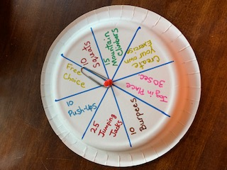

You will need: Paper Plate
Push Pin
Paper Clip

You can use the exercises that I have listed or you can choose your own! Please complete at least 5 spins (exercises) each day. If you don’t have the supplies to make the spinner, that’s okay. Just choose at least 5 exercises and do them. Have fun and stay active!

Mrs. Rosenthal

