
GLOBAL
FOCUS
An Unexpected Currency for Ukraine
In the early 1990s, the formerly united Soviet Union divided into separate countries. When this occurred, the Russian ruble was no longer the monetary unit for some of the newly independent nations.
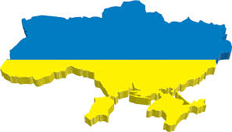
While the people of Ukraine were waiting to convert to a new currency, the need to have money in circulation was critical. To prevent a financial crisis, the Ukrainian government issued coupons for use in buying the country’s limited supplies of food and other products. These coupons, called Karbovanets, were not originally intended to be the new Ukrainian currency. However, as Ukraine’s economy developed, these coupons became widely accepted as money. At first, Ukrainians were using both the coupons and the Russian ruble. As the new monetary system replaced the old one, rubles became less acceptable for making purchases. The acceptance of the ration coupons made them the unofficial currency of Ukraine.
The use of these coupons as legal tender eventually ended. Today Ukraine’s currency is the hryvnia. This word, used since the eleventh century, comes from the word that originally referred to the valuable things worn around the neck. Introduced in 1996, the hryvnia has been one of the most stable currencies in this region of the world.
To build on the stable monetary value and expand the country’s economic development, the World Bank has provided Ukraine with several loans. These funds helped to improve the country’s agricultural productivity and to expand food product exports especially grains, sugar, beets, and vegetables.
Think Critically
1. What problems can occur in an economy that does not have enough money in circulation?
2. What made the ration coupons valuable in the Ukrainian economy?
3. What made the Russian ruble less acceptable among Ukrainians?

